Front-End UI/UX Mini Project

**Project Submission Template**

**1. Title Page**

* **Project Title**: *RESTAURANT Landing Page"*
* **Submitted By**: 
  + *Sanjay Sj 2463049- sanjay.sj@btech.christuniversity.in*
  + *Pranav 2463055-shree.pranav@btech.christuniversity.in*
  + *Kevin Biju 2463033-biju.kevin@btech.christuniversity.in*
* **Course**: *e.g., UI/UX Design Fundamentals*
* **Instructor Name**: *Dhiraj*
* **Institution**: *e.g., Christ University*
* **Date of Submission**: *13/08/2025*

**2. Abstract**

This project involves designing and developing a responsive restaurant landing page using only HTML5 and CSS3. The goal was to create an engaging and visually appealing interface that highlights the restaurant’s brand identity, menu highlights, and contact details. The website was built with a mobile-first approach to ensure a seamless user experience across devices. Key features include a hero section with a restaurant tagline, menu showcase cards, and a reservation/contact form layout. The design prioritizes clarity, color harmony, and visual hierarchy to entice potential customers and improve accessibility

**3. Objectives**

Clearly list the project goals:

* Design a user-friendly interface using modern UI principles
* Develop a fully responsive layout using only HTML and CSS
* Implement structured HTML5 semantic elements
* Apply CSS styling for branding, layout, and responsive behavior
* Ensure accessibility and readability across devices

**4. Scope of the Project**

• Focused exclusively on front-end design and layout.

• No JavaScript or back-end functionality implemented.

• Optimized for multiple screen sizes (mobile, tablet, desktop).

• Used only open-source tools and pure HTML/CSS code without frameworks.

**5. Tools & Technologies Used**

|  |  |
| --- | --- |
| Tool/Technology | Purpose |
| |  |  | | --- | --- |   HTML | Markup and content structure |
| CSS3 | Styling and layout management |
| VS Code | Code editor |
| Chrome DevTools | Testing and debugging |

**6. HTML Structure Overview**

• Used semantic tags: <header>, <nav>, <main>, <section>, <footer>.

• Sections included: Hero, About, Menu, Gallery, Contact.

• Navigation menu implemented with <ul> and internal links for smooth scrolling

**7. CSS Styling Strategy**

• External stylesheet (style.css) for maintainability.

• Organized code into sections with comments for readability.

• **Techniques used:**

* Flexbox and Grid for layout arrangements.
* Media queries for responsive adjustments.
* CSS variables for consistent theming.
* Hover effects for buttons and menu items.
* Mobile-first design approach.

**8. Key Features**

|  |  |
| --- | --- |
| Feature | Description |
| |  | | --- | | Responsive Design | | |  |  | | --- | --- | |  | adapts to all screen sizes. | |
| |  | | --- | | Hero Banner | | |  |  | | --- | --- | |  | intro with restaurant name and tagline. | |
| |  |  | | --- | --- | | Menu Section | Grid-based layout | | |  |  | | --- | --- | |  | showcasing dishes with images. | |
| |  |  | | --- | --- | | Contact/Reservation Form |  | | |  |  | | --- | --- | |  | for customer details (non-functional). | |
| |  |  | | --- | --- | | Accessible Colors & Fonts |  | | |  |  | | --- | --- | |  | High-contrast palette and readabletypography. | |

**9. Challenges Faced & Solutions**

|  |  |
| --- | --- |
| Challenge | Solution |
| Overlapping elements on small screens | Used media queries to stack elements |
| Difficulty aligning items using float | Shifted to Flexbox and Grid |
| Typography scaling issue | Used relative units (em/rem) instead of px |

**10. Outcome**

• Developed a visually appealing and functional landing page for a restaurant.

• Achieved consistent design aesthetics across devices.

• Gained hands-on experience in responsive design and front-end layout structuring

**11. Future Enhancements**

* Add JavaScript for interactivity (form validation, dynamic content)
* Integrate animations or transitions
* Backend integration for form submission
* Theme toggler (light/dark mode)

**12. Sample Code**

*<!DOCTYPE html>*

*<html lang="en">*

*<head>*

*<meta charset="UTF-8">*

*<meta name="viewport" content="width=device-width, initial-scale=1.0">*

*<title>Delish Restaurant</title>*

*<link rel="stylesheet" href="style.css">*

*</head>*

*<body>*

*<!-- Navigation -->*

*<header>*

*<nav class="navbar">*

*<div class="logo">Delish</div>*

*<ul class="nav-links">*

*<li><a href="#home">Home</a></li>*

*<li><a href="#about">About</a></li>*

*<li><a href="#menu">Menu</a></li>*

*<li><a href="#contact">Contact</a></li>*

*</ul>*

*</nav>*

*</header>*

*<!-- Hero Section -->*

*<section id="home" class="hero">*

*<div class="hero-content">*

*<h1>Welcome to Delish Restaurant</h1>*

*<p>Where taste meets perfection.</p>*

*<a href="#menu" class="btn">Explore Menu</a>*

*</div>*

*</section>*

*<!-- About Section -->*

*<section id="about" class="about">*

*<h2>About Us</h2>*

*<p>At Delish Restaurant, we craft mouth-watering dishes with fresh ingredients and love. Our chefs bring culinary excellence to every plate, ensuring you enjoy an unforgettable dining experience.</p>*

*</section>*

*<!-- Menu Section -->*

*<section id="menu" class="menu">*

*<h2>Our Menu</h2>*

*<div class="menu-items">*

*<div class="item">*

*<h3>Grilled Chicken</h3>*

*<p>Juicy chicken served with seasonal veggies.</p>*

*<span>$12.99</span>*

*</div>*

*<div class="item">*

*<h3>Veggie Pasta</h3>*

*<p>Pasta tossed in a creamy herb sauce.</p>*

*<span>$9.99</span>*

*</div>*

*<div class="item">*

*<h3>Chocolate Lava Cake</h3>*

*<p>Warm chocolate cake with a molten center.</p>*

*<span>$6.50</span>*

*</div>*

*</div>*

*</section>*

*<!-- Contact Section -->*

*<section id="contact" class="contact">*

*<h2>Contact Us</h2>*

*<p>📍 123 Food Street, Flavor Town</p>*

*<p>📞 (123) 456-7890</p>*

*<p>📧 contact@delish.com</p>*

*</section>*

*<!-- Footer -->*

*<footer>*

*<p>© 2025 Delish Restaurant | All Rights Reserved</p>*

*</footer>*

*</body>*

*</html>*

**13. Screenshots of Final Output**

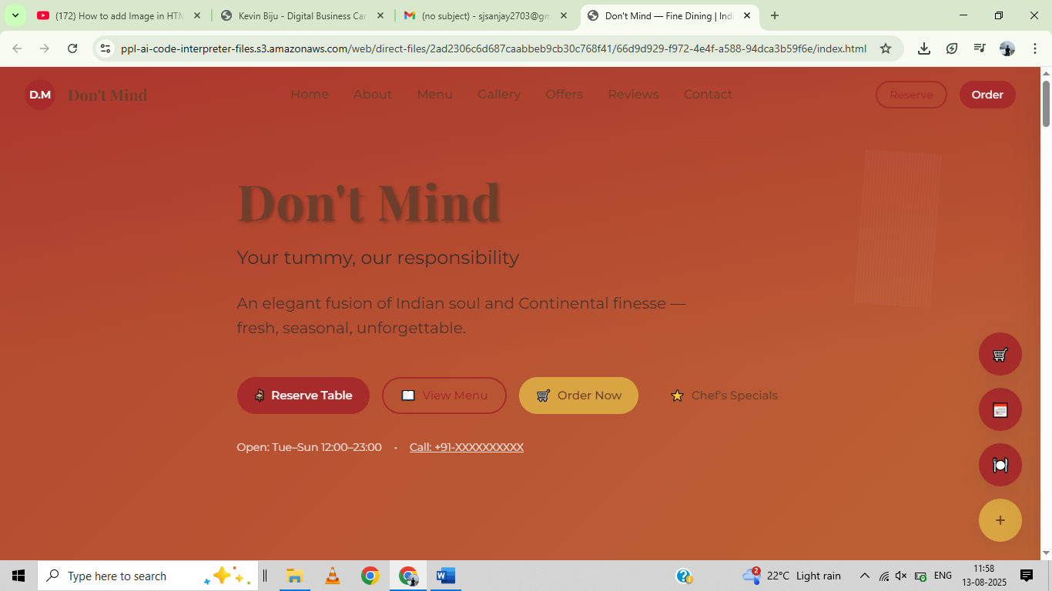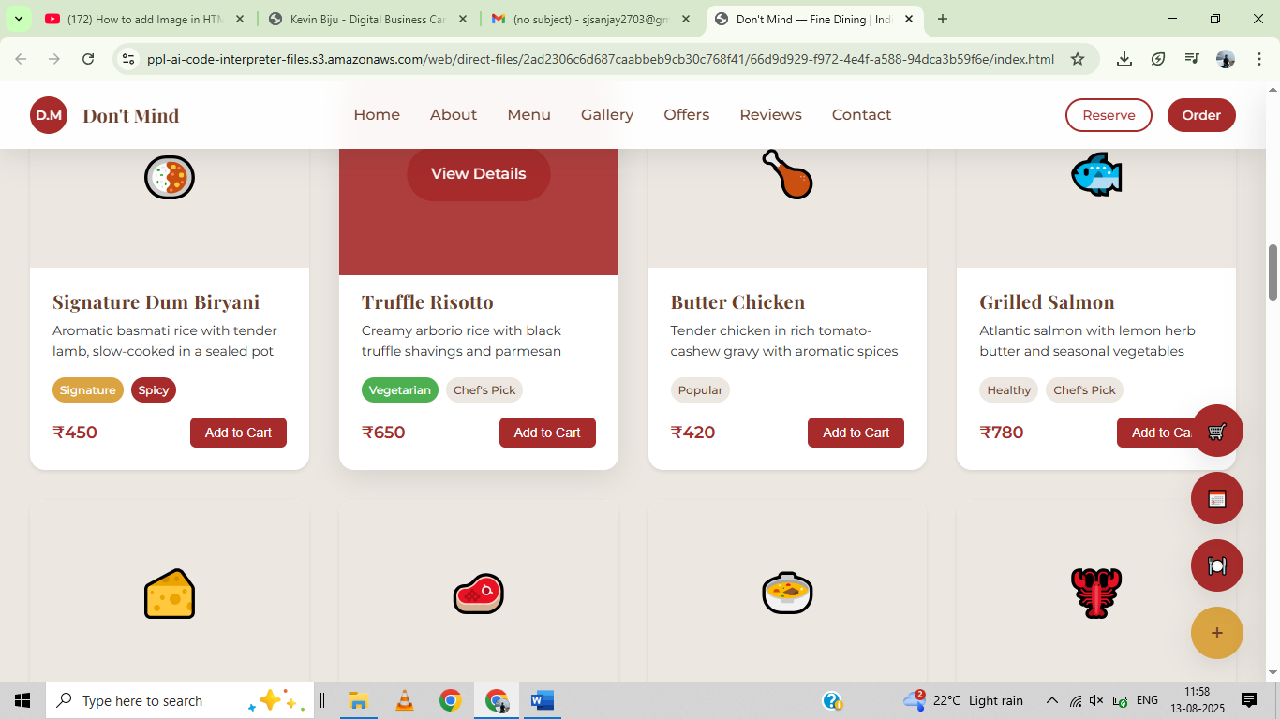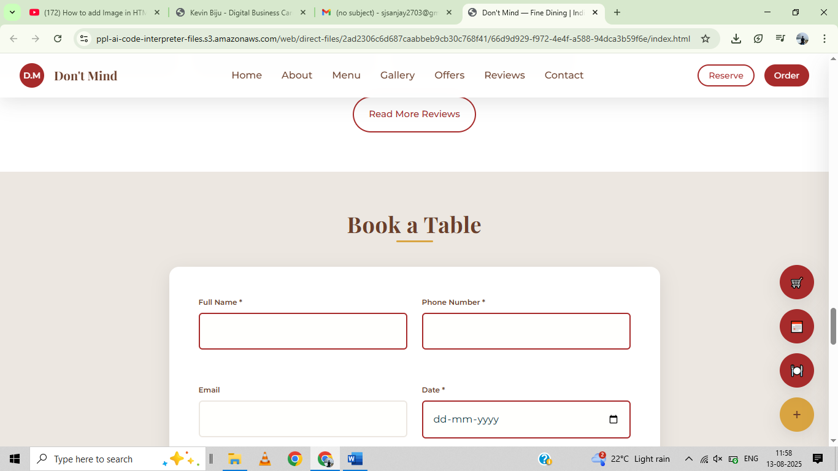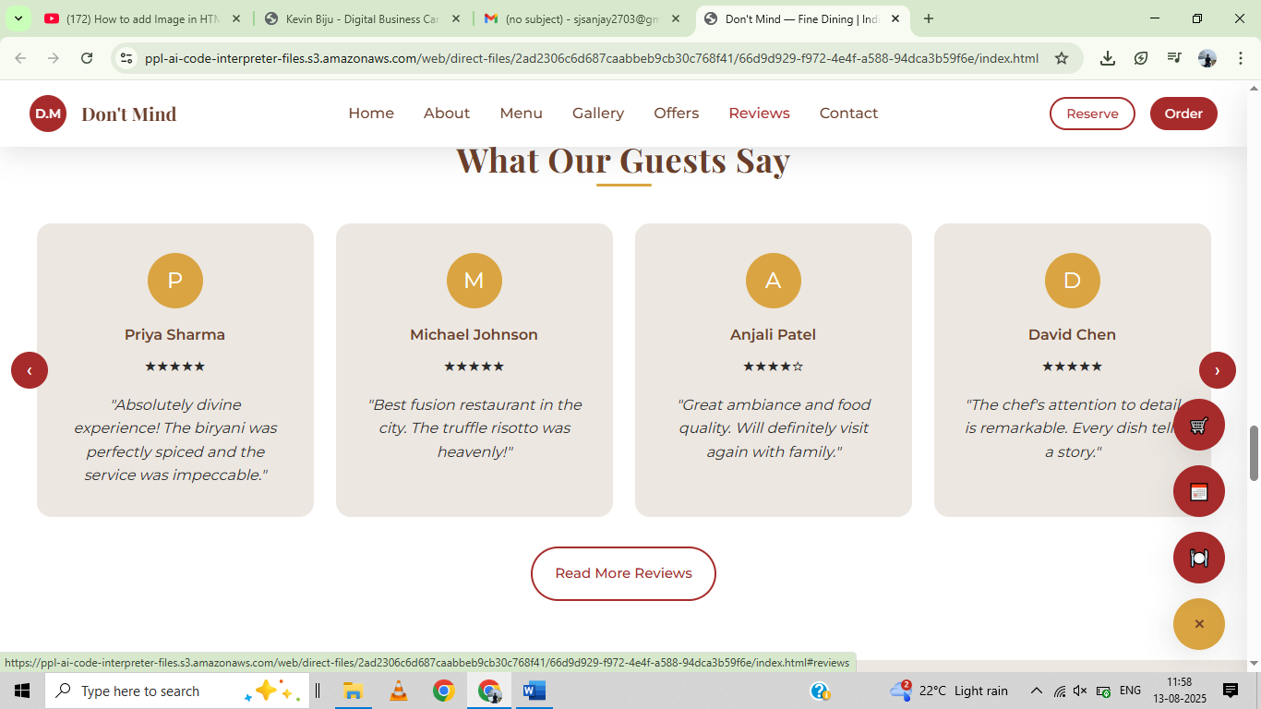

**11. Conclusion**

The Responsive Restaurant Landing Page project successfully demonstrates the ability to design a clean, modern, and user-friendly website using only HTML and CSS. The project enhanced our understanding of layout structuring, responsive adjustments, and the importance of branding in web design. By focusing solely on front-end development, we gained practical skills in visual hierarchy, typography, and color usage for a real-world application.

**12. References**

* L&T LMS : <https://learn.lntedutech.com/Landing/MyCourse>

• W3Schools HTML & CSS Documentation

• MDN Web Docs (Mozilla Developer Network)